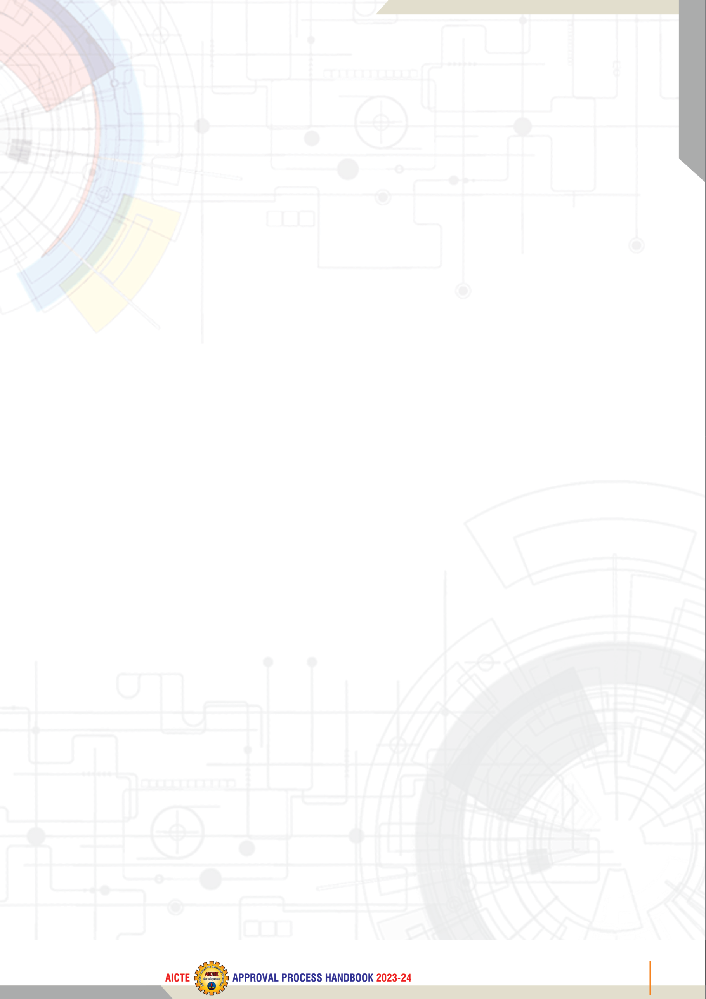
MandatoryDisclosures

ThefollowinginformationshallbegivenintheinformationBrochurebesidesbeinghostedontheInstitution’sofficialWebsite.

TheonusoftheauthenticityoftheinformationlieswiththeInstitutionONLYandnotonAICTE.

NameoftheInstitution
LBSModel Degree College.
NCC road junction, Thanur road,
Parappanangadi, Malappuram
Kerala 676303
Phone No : 0494 2430135
e-mail : lbsiistpgimdc@gmail.com

NameandaddressoftheTrust/Society/CompanyandtheTrustees
LBSCentreforScience&Technology
Palayam,Thiruvananthapuram.
PhoneNo:-0471–2324396,
FaxNo:-0471-2337055
E-Mail:-director.lbs@kerala.gov.in

NameandAddressofthePrincipal
Dr.Rameshan P.
LBS Model Degree College.
NCC road junction, Thanur road,
Parappanangadi, Malappuram
Kerala 676303
Phone No : 0494 2430135
e-mail : principal@lbsmdc.ac.in

NameoftheaffiliatingUniversity

University of Calicut,

Thenhipalam, Malappuram,

Kerala, 673635,

- Governance
  - Organizationalchart
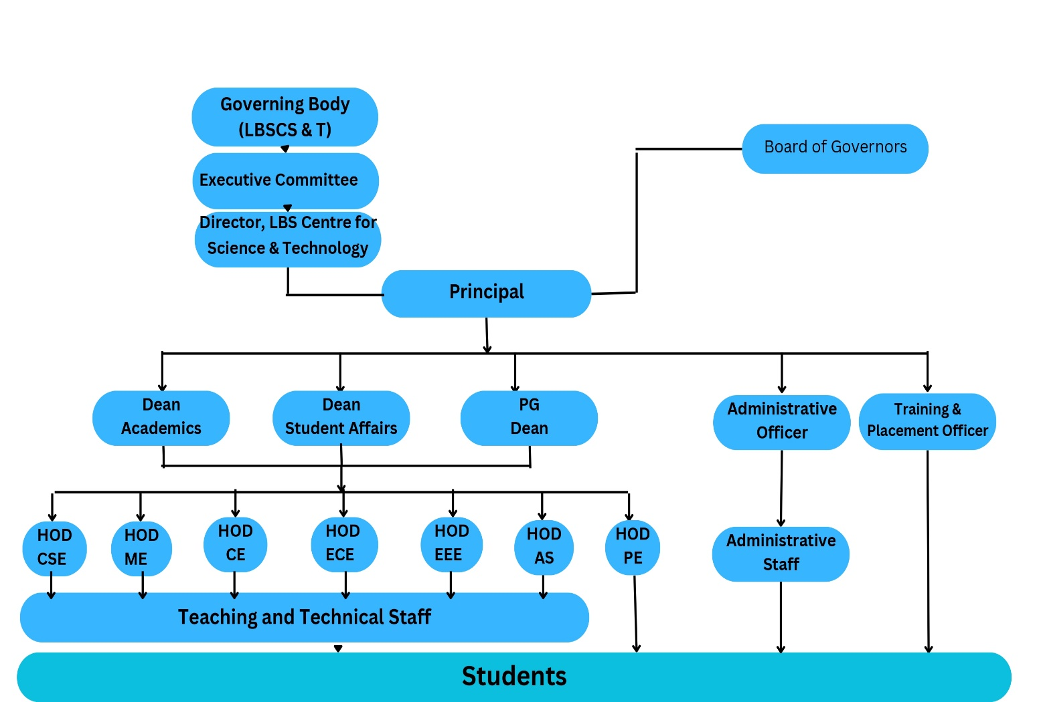

b | GoverningBody  (LBS Centre for Science and technology) | Chairman:Hon’bleChiefMinister,  Vice Chairman: Hon’ble Minister for Higher Education  MemberSecretary:Director,L.B.S.CentreforScienceandTechnology,  Othermembers  PrincipalSecretariestoGovt.HigherEducation,FinanceandIndustriesdepartments  Director of Technical Education, Govt. of Kerala  HeadofOfficeofvariousGovt.bodiesandIndustrialOrganizations
c | ExecutiveCommittee  (LBS Centre for Science and technology) | Chairman:PrincipalSecretarytoGovt.,HigherEducation  ViceChairman:DirectorofTechnicalEducation  MemberSecretary:Director,L.B.S.CentreforScienceandTechnology,  Members  PrincipalSecretarytoGovt.,FinanceDept.orhisNominee  Principal,CollegeofEngineering,Thiruvananthapuram.  ChiefExecutive,Technopark,Thiruvananthapuram.  ManagingDirector,TTPL,Thiruvananthapuram.

  - GrievanceRedressalmechanismforFaculty,staffandstudents

Students’ grievance redressal committee (sgrc)
The Students’ Grievance Redressal Committee (SGRC) is established to address and resolve issues or concerns raised by students related to both academic and non-academic matters. The primary objective is to ensure the redressal of grievances in a fair and impartial way maintaining confidentiality.
The members of the committee are
Name& Designation | Position | Contact No | E-mail id
The members will meet at least once in every two months or on receipt of a grievance. The committee will review the grievance and recommend appropriate action to be taken by the Head of the Institution. The cell is committed to maintain the confidentiality of information throughout the process.

OnlineGrievanceRedressalMechanism
Any aggrieved student can drop their grievances in the complaint box placed in front of the office.

Anti Ragging Cell
Definition of Ragging
“Any disorderly conduct whether by words spoken or written or by an act which has effect of teasing, treating or handling with rudeness any other student, indulging in rowdy or indisciplined activities which causes or is likely to cause annoyance, hardship or psychological harm or raise fear or apprehension thereof in a fresher or a junior student or asking the students to do any act or perform something which such student will not do in the ordinary course and which has the effect of causing or generating a scene of shame or embarrassment so as to adversely affect the physique or psyche of a fresher or junior student.” An anti-Ragging squad has been constituted to maintain the campus ragging-free and to make the students aware of consequences of ragging.

Anti Ragging Committee

InternalQualityAssuranceCell
Objectives
To develop and implement quality bench marks for academic activities of the institution to create a student-centric environment for quality education.
Functions
- Setting of parameters for various academic activities of institution.
- Creation of learner centric environment to ensure quality education.
- Collection and analysis of feed-back on quality related processes.
- Periodic conduct of academic and administrative audit.
- Suggest measures to improve quality based on feed-back and audits

Programmes

Faculty
LIST OF FACULTY MEMBERS APPOINTED DISCIPLINE WISE
Department of Applied Science

- ProfileofPrincipal
Name :
Highest :PhD
DateofJoining :
StatusasondateofJoining :PROFESSOR
PresentStatus :PROFESSOR
UniqueID :
- Fee
Timeschedulefor paymentoffee fortheentire programme:Annual

SL.  No. | Category | CETquota |  | Managementquota
SL.  No. | Category | Fixed by theState FeeCommittee.(Rs.) | Beingcharged bytheInstitution (Rs.) | FixedbytheState FeeCommittee (Rs.) | BeingchargedbytheInstitution(Rs.)
1. | Admission Fee
2. | TuitionFee
3. | UniversityAﬃliationFee
4. | Recognition& Matriculation
5. | Identity Card Fee
6. | SpecialFee
7. | PTAMembershipFee
8. | DepartmentalAssociationFee
9. | Caution Deposit
10. | Co-operativeSociety
11. | Hostel Fee (RefundableDeposit, Advance Rent,EstablishmentCharge&Admission Fee)
12. | Career Guidance &Placement
TotalFee

No. of Scholarship offered by the institute, duration & amount

- Admission
Sl. No | Year | Sanctioned seats
Sl. No | Year | UG
1
2
3

No. of applications received during the last two years for admission under management quota
and number admitted.
Admission Procedure
Criteria and Weightages for admission:
Application Form :
Merit Seats :
Results of admission under management
seats / Vacant Seats

Information on infrastructure and other resources available

Details of library facilities:

Sl. No. | Name of the course | Name of the Laboratory/ Workshop | Total Area of Lab/ Workshop (m2)

Games & Sports facilities
Outdoor - Foot ball, Cricket, Base ball

Extra-Curricular Activities
Co-curricular activities play an important role in the development of vision and shape the intellect, personality, emotional strength, morals, and humility of a student. Our students have immense talents in co-curricular and extra-curricular activities. In this regard, the institution has formed various student committees for participating and organizing the technical, cultural, and sports activities
Student Clubs
NSS Activities
The National Service Scheme (NSS) Unit takes pride in its students participating in many service activities. They include observance of National days, conduction of awareness programs, community services, college activities, etc. Through these activities, NSS Cell inculcates among students a spirit of belongingness to the society around them, teaches them leadership skills, develops communication skills and encourages them to be good human beings.

